08

**Fall**

George Washington’s Mount Vernon “Be Washington” AV Theater and Web

CMS Manual Guide

Section 1 – CMS Overview 3

Section 1.1 Connecting to the CMS 3

Section 1.2 Logging In 3

Section 1.3 Main Navigation Menu 3

Section 1.4 WARNING: Saving Changes to CMS 4

Section 1.5 Video Resolutions 4

Section 1.6 Note on backup videos 4

Section 2 – Scenario Content 5

Section 2.1 Content of Scenario 7

Section 2.1.1 General 8

Section 2.1.2 Introduction Tab 9

Section 2.1.3 Advisers Tab 10

Section 2.1.4 Timer Events Tab 15

Section 2.1.5 Questions and Answers Tab 17

Section 2.1.6 Voting Results Tab 19

Section 2.1.7 Conclusion Tab 21

Section 2.1.8 Outro Tab 22

Section 3 Web Only Data 24

Section 4 Settings 24

Section 5 User Profile 26

# – The CMS Overview

## Connecting to the CMS

To connect to the Content Management System (CMS), open any web browser window.

In the address bar input the following address: http://52.70.145.157/BeWashingtonNew/Account/Login. This will take you directly to the Home Page. The Home Page contains the CMS version number and access to the tabs that govern each section of the CMS. If you are already logged in, you will be able to navigate to these sections with the tabs in the navigation bar at the top of the page. If you are not logged in, you will need to click the **Log In** prompt in the top right corner of the page.

## Logging In

If you click **Log In** from the **Home Page,** or any other section of the CMS, you will be presented with the **Log In Prompt**. You are required to enter your user name and password to continue. Your credentials can be saved on the system you are accessing the CMS on by checking the **Remember Me?** check-box before clicking the **Log In Button**.

If you have saved your credentials, you will not be required to log in to the CMS every time and will be able to navigate directly to the section you want to work with. Otherwise, you will be prompted each time you visit the CMS.

## Main Navigation Menu

The **Main Navigation Menu** directs you to the individual sections and administrative functions. Below is a brief overview of each tab.

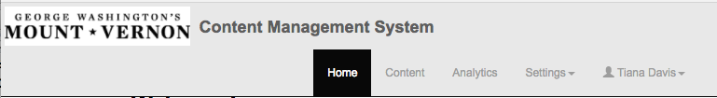

## WARNING: Saving Changes to the CMS

If you open the CMS to browse without making changes, **PRESS** **CANCEL**, **NOT SAVE** after you’re done.Every time the SAVE button is pressed, it overwrites the timestamp of the JSON. Theater kiosks will cache from the CMS each morning when it detects the timestamp has been changed.

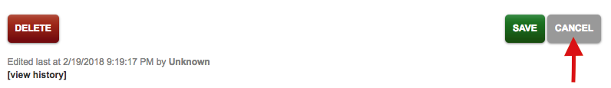

## Video Resolutions

For the purposes of this guide, all Main Wall videos are 5760 x 1512 pixel HAP MOV files. All Web videos are 1920 x 1080 pixel H.264 MP4 files.

## Note on backup videos

Backups are videos hosted on the CMS in case web users’ firewalls blocks Vimeo. These files are the same MP4s that were uploaded to Vimeo. When uploading an MP4 file to the CMS, you will be able to see the thumbnail and preview the video.

# – Scenario Content

The Content tab at the top of the page allows an administrator to manage all of the content within the interactive, both in the theater and online.



You will know you are in the correct section when you see the **Scenario** tab on the left is filled White as opposed to filled Gray (see: Web Only Data).

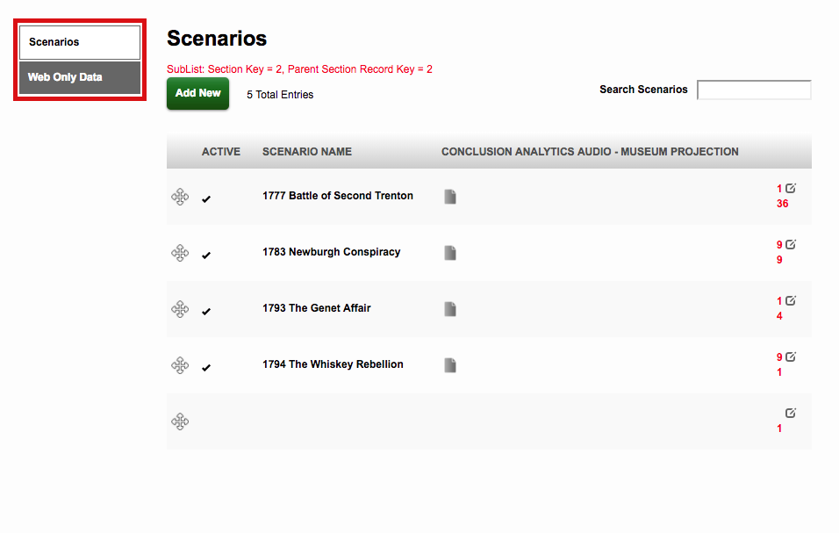

You will also notice the crossed arrows (crosshairs) under the Active column. If you press and hold the crosshairs, you can then drag the row, which will rearrange the order the scenarios will appear in when in loop mode.

**Active Status**

All scenarios that are live in the game will have a check mark under the **Active** column. Should a scenario be deactivated, the check mark will disappear.

**Scenario Name**

All content that appears in Be Washington is associated with one of the **Scenario Names.** Selecting one of the **Scenario Names** will allow you to edit the content associated with that scenario.

When you hover your mouse on one of the **Scenario Names**, that scenario row should turn Gray, meaning you can select it to begin editing the content.

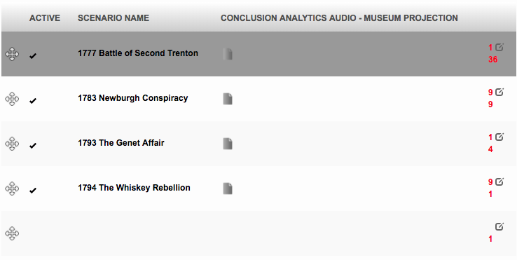

## Editing a Scenario

After clicking on one of the **Scenario Names**, a pop-up will appear. This is where you will begin to edit content.

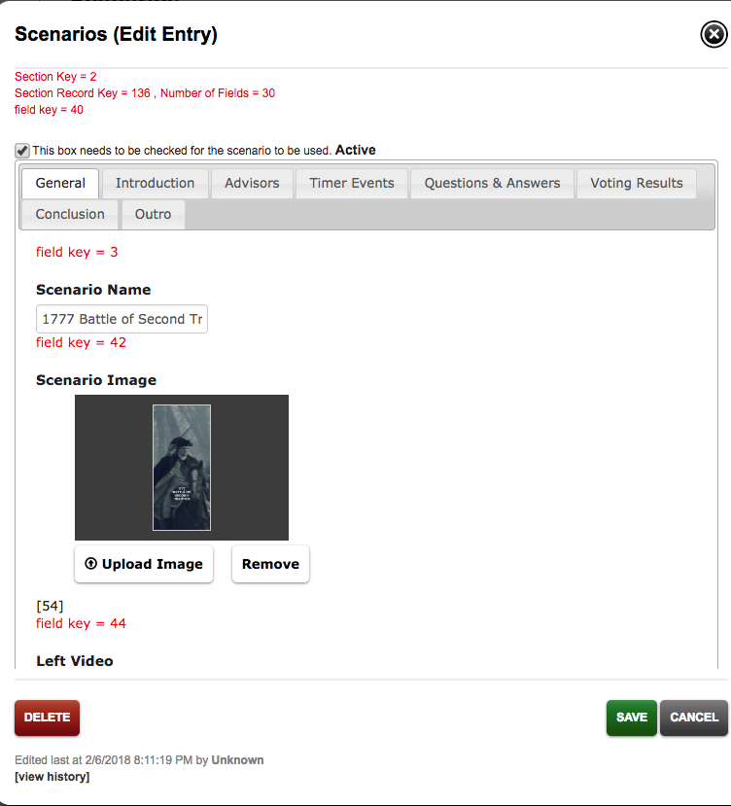

**NOTE:** At the top of the popup, you will see a box with text that reads, “This box needs to be checked for the scenario to be used. **Active.**” Removing the check from this box deactivates the scenario, **meaning that it will not be playable**.

### General

In the scenario popup, under the **GENERAL** tab is where you will find the Scenario Name, Scenario Image, Front Wall – Left Adviser Video, Front Wall – Right Adviser Video, and the Welcome Screen Image.

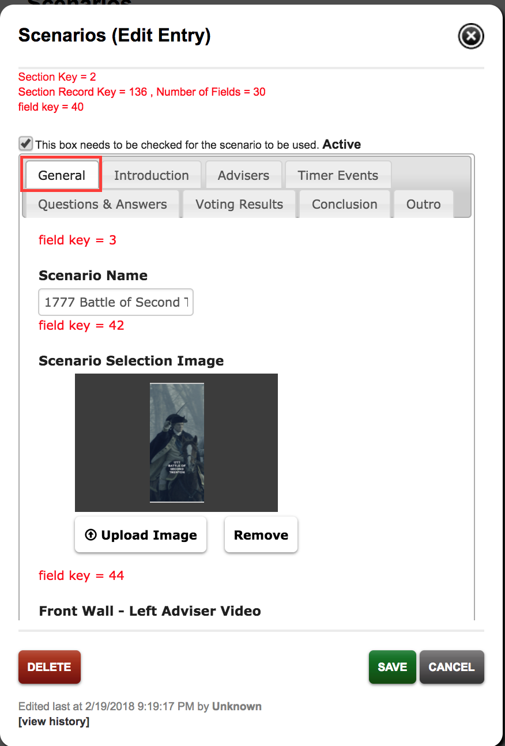The **Scenario Name** is where the name of each scenario goes. The Year always goes first, followed by the name in title case.

The **Scenario Selection Image** is the image that allows an educator or host to select a scenario. The image must be a 480 x 1080 JPEG.

The **Front Wall – Left Adviser Video** always shows 4 advisers on the left side of the theatre front wall screen. This video must be an 8000 pixel HAP MOV file. **NOTE:** When uploading HAP videos to the CMS, please remember that neither a preview nor a thumbnail will be available.

The **Front Wall – Right Adviser Video** always shows either 3 OR 4 advisers on the right side of the theatre front wall screen. This video must be an 8000 pixel HAP MOV file.

The **Welcome Screen Image** is the background image for all theatre kiosks and web products during the introduction for each scenario. This image must be a 1920 x 1080 JPG file.

### Introduction Tab

Under the **INTRODUCTION** tab, you will find the Front Wall Countdown Video, Countdown Video – Museum Kiosk, Front Wall Introduction Video, an Introduction Video – Web (Streaming Link), and an Introduction Video – Web (Backup) video.

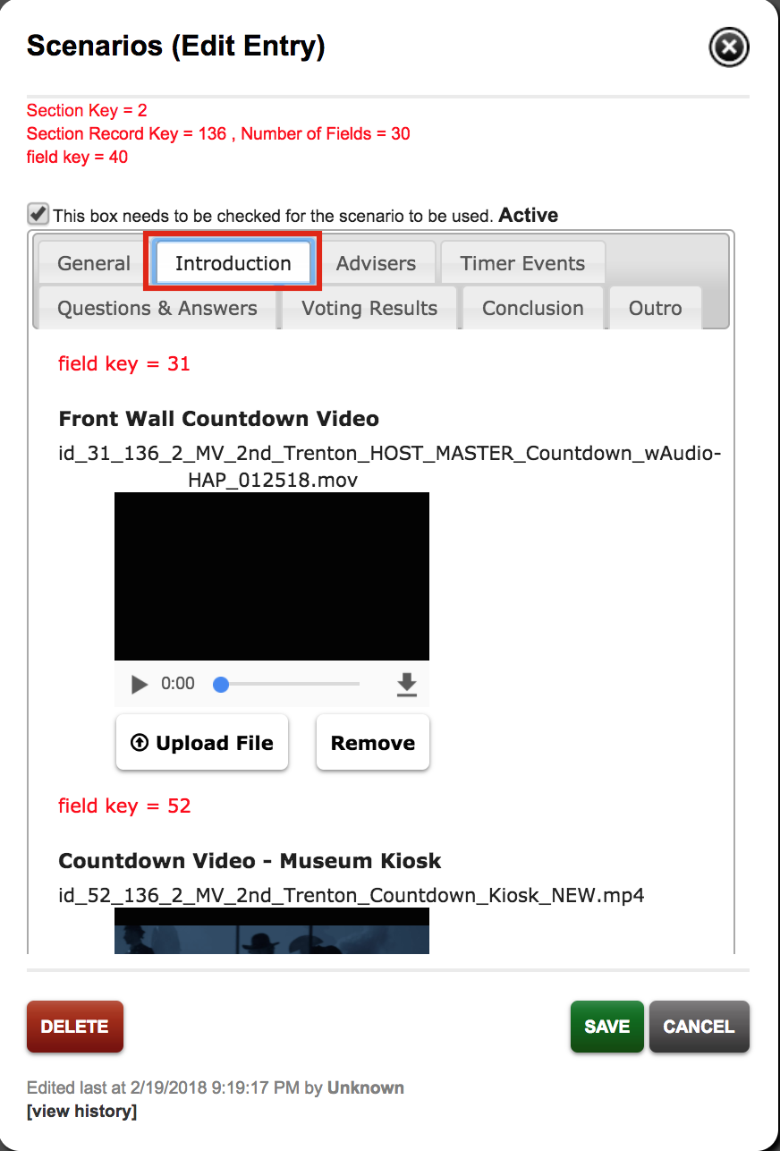The **Front Wall Countdown Video** is the content that will be seen between scenarios in the main theater. This video must be a HAP MOV file. It is 1:30 of countdown and 10 seconds of donor recognition. This video does not exist in educator mode.

The **Countdown Video – Museum Kiosk** is the content that will be seen between scenarios on the 18 kiosks. It is 1:40 min long. This is an MP4 file.

The **Front Wall Introduction Video** shows the host introducing the audience to the Be Washington experience. This video must be a HAP MOV file.

The **Introduction Video – Web streaming link** is the Vimeo link to the introduction video for those who experience Be Washington on the web. This is an MP4 file.

The **Introduction Video – Web backup** is the back up introductory video for web users. This is an MP4 file.

### Advisers Tab

Under the **ADVISERS** tab, you’ll see the Front Wall Gameplay Music. Below that, you will see a list of all of the advisers for that particular scenario.

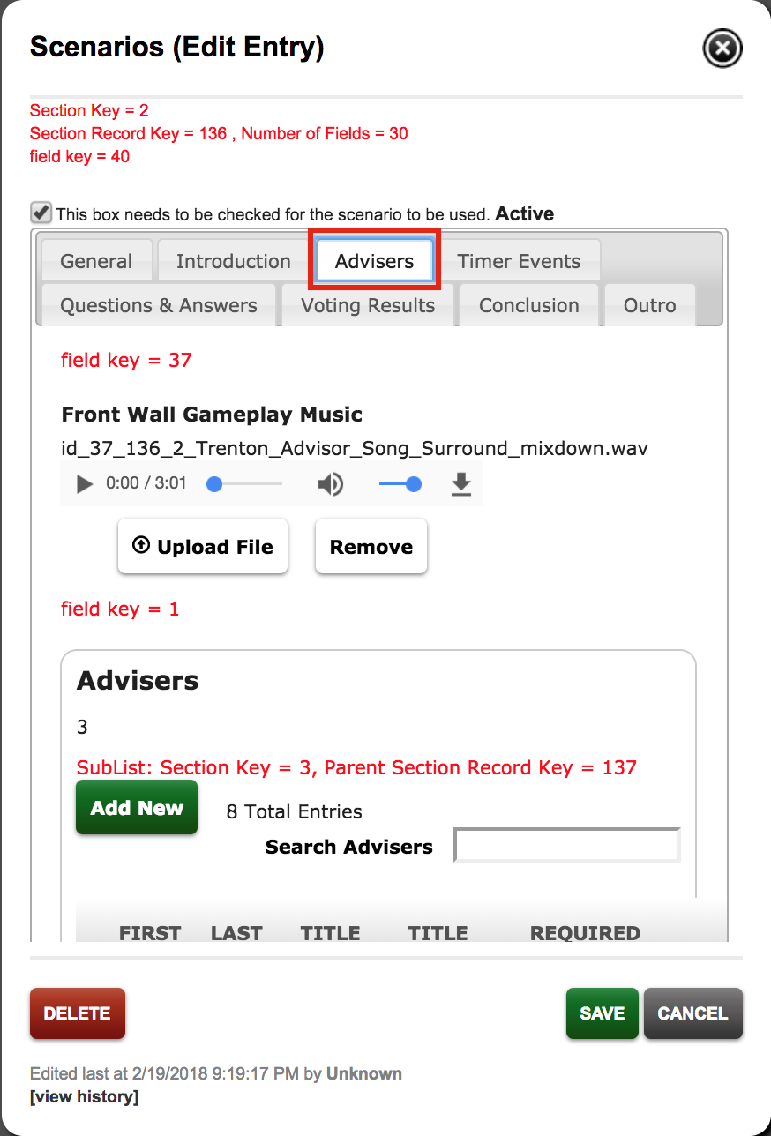

The **Front Wall Gameplay Music** is the music the players will hear while they are listening to advisers in the theatre. This audio is a 5.1 surround WAV file.

When you hover your mouse on one of the adviser’s names, it will turn blue, signifying that you can select that adviser.

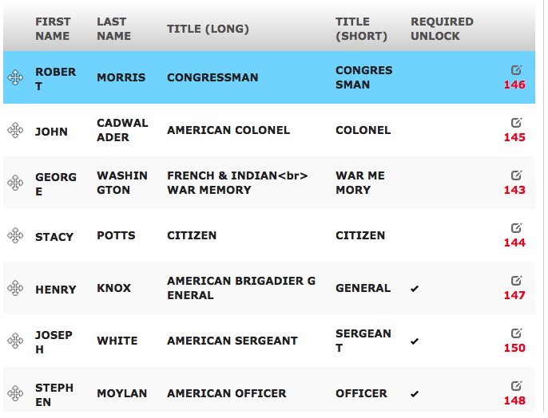

At the bottom of the list, you will notice that the last few advisers have a checkmark to the right of their names. This checkmark indicates that those particular advisers are unlocked after a dispatch, instead of showing up at the beginning of the game.

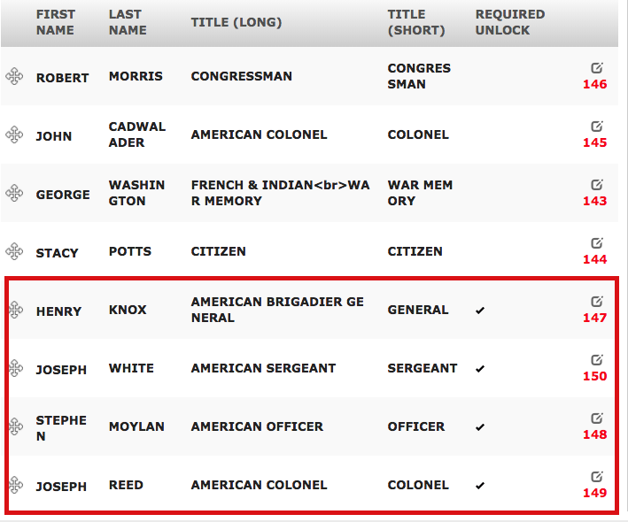

**NOTE:** You’ll notice the crosshairs appear to the left of the advisers’ names. As before, clicking and dragging these crosshairs will change the order of the advisers. Changing the order of the advisers will change how they appear on screen. This will affect ALL Be Washington products. **We warn against changing the order of the advisers**.

#### Editing Advisers

Once you click on an adviser’s name, the **Advisers (Edit Entry)** window will open. This window is where you will be able to edit content related to each individual advisor. Here is where you will have the ability to edit the adviser’s First Name, Last Name, change the Name Menu Alignment, the advisor’s Title (Long), the advisor’s Title (Short), Opinion, Gender, Face Image, Full Body Image, Museum Video, and a Web Link to the character’s video, along with a backup. At the very bottom of the page is the Required Unlock box.

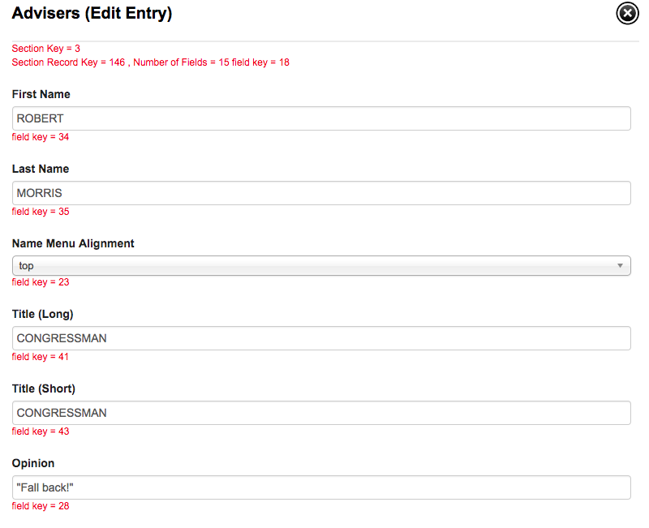The **First Name** box is where you type the adviser’s first name in ALL CAPS. The max character count for this box is 13 characters.

The **Last Name** box is where you type the adviser’s surname in ALL CAPS. The max character count for this box is 13 characters.

**Name Menu Alignment** changes the position of the adviser’s name on their body. This only affects kiosks.

**Title (Long)** is where you put that adviser’s full title or profession. The max character count for this box is 27 characters.

**Title (Short)** is where you put the shortened title for that adviser. The max character count for this box is 19 characters.

In the **Opinion** box, you will find that adviser’s opinion on the particular scenario. All opinions must be inside quotation marks.

The **Gender** selection tells us which gender the adviser is.

The **Face Image** is a headshot for each adviser. This image is used at the end of the experience when users are voting. This is a 2100 x 1440 pixels PNG file with transparency.

The **Body Image** is a full body shot of the adviser. These are 1000 x 1440 pixels JPGs. There is an Active version and an Inactive version. Active images are in color; inactive images are in gray scale.

The **Museum Video** is an H.264 MP4 that shows the adviser speaking to the audience.

The **Video Web Link** is a link to the Vimeo video for web users.

The **Video Web backup** video is an H.264 MP4 video.

When you scroll to the very bottom, you will see a box saying, “Check this box if the character is unlocked after a dispatch **Required Unlock.**” This box should be checked ONLY for advisers that appear after the first dispatch.

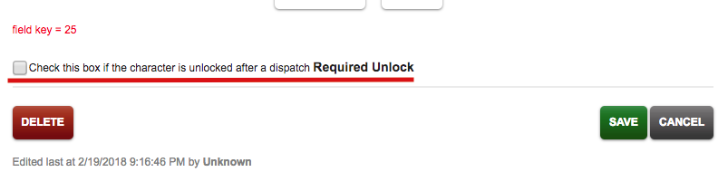

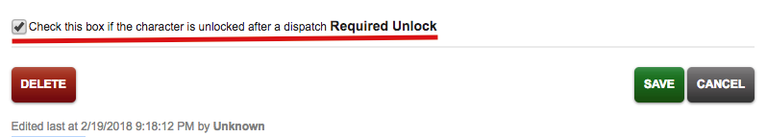

### Timer Events Tab

The **Timer Events** tab is where you find information on how long each round of play lasts. This is also where the dispatch videos are uploaded.

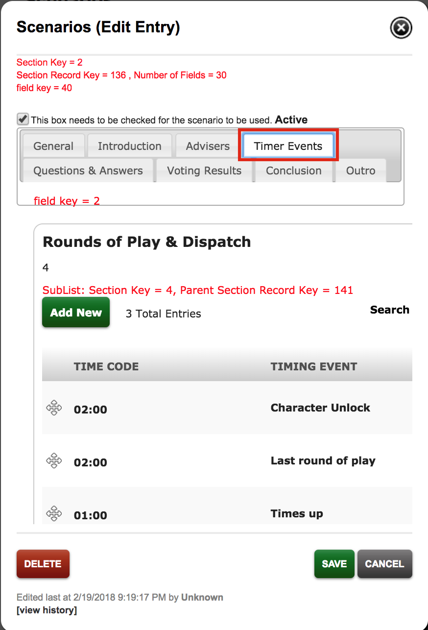Time Code refers to how long each round of play (Character Unlock, Last Round of Play, and Time’s Up) lasts. Timing Event refers to the name of each round of play.

When you click the name of a round of play you will enter a new pop-up window where you can edit information pertaining to Time Code, and Timing Event, as well as uploading the Front Wall Dispatch Video, Web Projection Video with a backup, and the Dispatch Background.

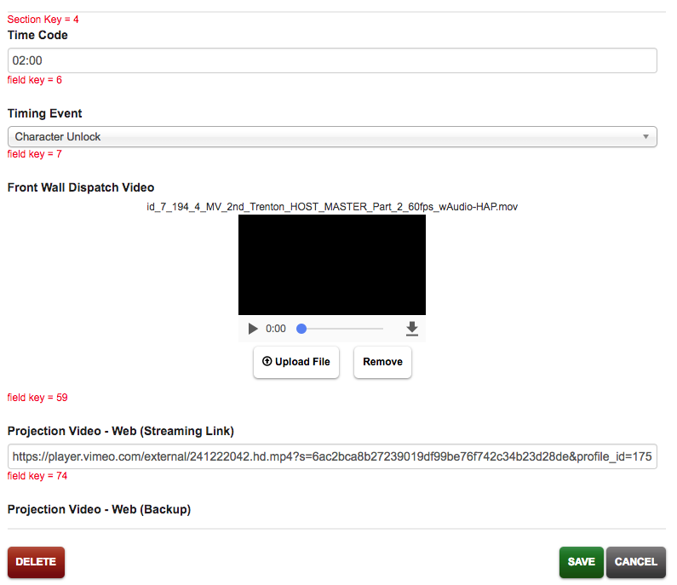**Time Code** tells you the length of time until the next event. Generally, this should be 2 minutes for each Dispatch and 1 minute for Times Up. Each scenario’s game clock will add the length of the three timed events to determine the desired length of the experience.

**Timing Event** tells you which round of play you’re in. Character Unlock leads up to the first dispatch. Last Round of Play leads up to the second dispatch. Time’s Up leads up to voting.

The **Front Wall Dispatch Video** field is where you upload your media. This is also a HAP MOV file.

The **Projection** **Video Web Link** links to Vimeo for those who are enjoying the web version of Be Washington.

The **Video Web Backup** is the backup video embedded in the CMS for web players.

At the very bottom, you will see the **Dispatch Background** field. This is the image shown on kiosks as the dispatch video plays. This is a 1920 x 1080 JPG.

### Questions and Answers Tab

When you click the **QUESTIONS AND ANSWERS** tab you will find the Time’s Up Audio for both the museum and web. When you scroll down, you will find the editable Question Text and the Pre-Decision Videos for both the museum and web. Scroll down a little more, and you will find the answer choices for that particular scenario, and the Final Question (Decision) Video for both museum and web.

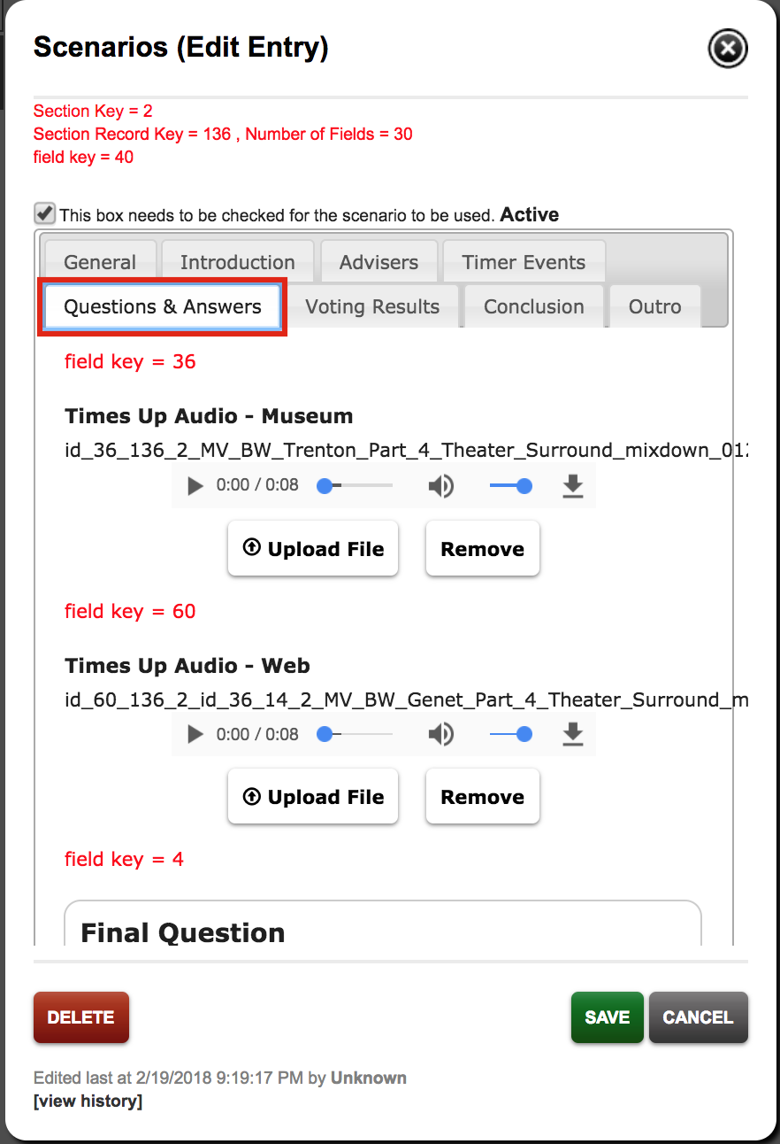The **Time’s Up Audio** **for the museum** is the host telling users “Times up” and it will soon be time to vote. This is a 5.1 surround WAV file.

The **Time’s Up Audio** **for the web** is the host telling you “Times up” and it will soon be time to vote. This is a stereo WAV file.

The **Question Text** shows the text that appears right above users’ three choices when voting. The max character count for this field is 36 characters.

The **Pre-Decision Video** for the museum features the host recapping a user’s three possible choices. This video is a HAP MOV file.

The **Pre-Decision Video** for the web is the Vimeo link for the players using the web version of Be Washington.

The **Pre-Decision** **Backup** is the backup for the pre-decision Vimeo link.

The **Answer Choices** will show the answers players will be able to choose from for that particular scenario. There can only ever be 3 possible answer choices for each scenario.

When you click the **Answer Choices** selection, you will get a popup. This gives you options for editing the Letter and the Answer Text.

**Letter** refers to what letter you want to assign to each answer choice.

**Answer Text** refers to the answer choices provided. The max character count for this box is 40 characters.

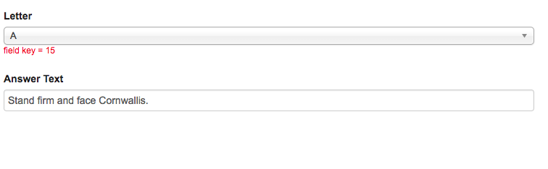

The **Ten Seconds to Vote** decision video for the museum is the timer that plays while players are voting. This video is a HAP MOV file.

The **Ten Seconds to Vote** decision video for the web is the Vimeo link for web players.

The **Ten Seconds to Vote** Backup is included beneath the Vimeo link.

### Voting Results Tab

Select the **VOTING RESULTS** tab, and you will see the Voting Results Videos. Further down, you will see the Front Wall Voting Results Text.

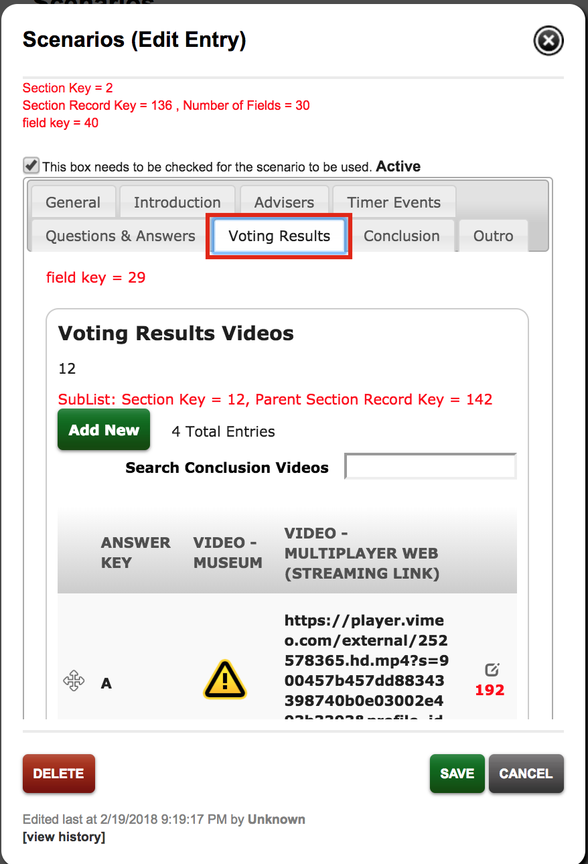The **Voting Results Videos** are videos of the host saying the majority of voters chose this answer. This video only plays on the front wall.

The **Front Wall Voting Results Text** is the text that appears at the end of the experience, during the analytics portion.

When you select one of the **Voting Results Videos** you will get a popup for content concerning Answer Key, Video-Museum, Video – Multiplayer Web link, Video – Multiplayer Web backup, Video – Singleplayer Web link, Video – Singleplayer Web Backup

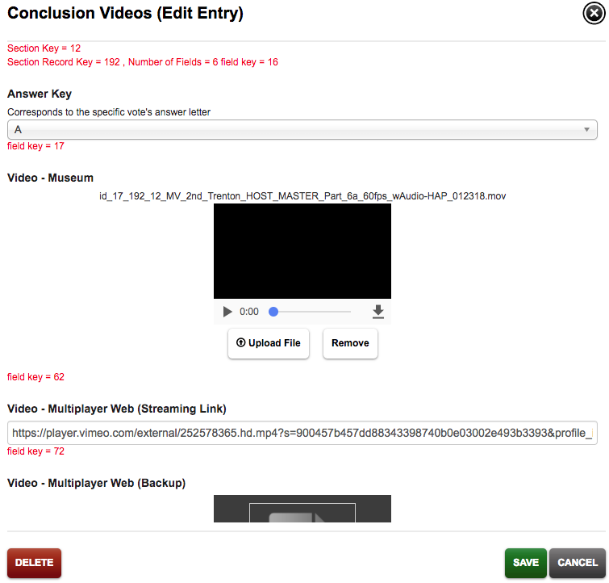**Answer Key** refers to the specific vote’s answer letter.

**Video – Museum** refers to the video of the host telling the players what the majority chose.

**Video – Multiplayer Web (Streaming Link)** is the Vimeo link for web players.

**Video – Multiplayer Web (Backup)** is the backup video for web players.

**Video – Singleplayer Web (Streaming Link)** refers to the video of the host telling the single player what they chose for the web.

**Video – Singleplayer Web (Backup)** is the backup for the web players’ Vimeo link.

When you click the **Front Wall Voting Results Text** selection, you get a popup for editing content pertaining to the Letter, Line 1, and Line 2.

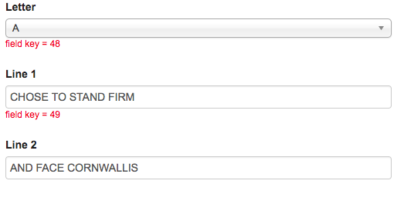**Letter** refers to the letter assigned to the answer choice.

**Line 1** refers to the first half of the answer choice. The max character count for line 1 is 29.

**Line 2** refers to the second half of the answer choice. The correct answer is always the one that has “Chose to lead like Washington…” for line 1. The max character count for line 2 is 40.

### Conclusion Tab

In the **CONCLUSION** tab, you will see the George Washington’s Choice video for both the museum and the web. You will also see the Conclusion Analytics Background (Front Wall) image and the Conclusion Analytics Audio – Museum Projection.

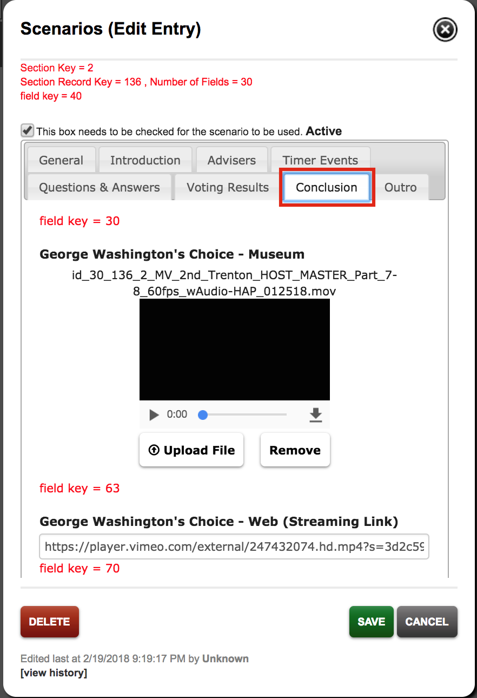**George Washington’s Choice** for the museum is the video that shows what Washington chose to do in each scenario. This is a HAP MOV file.

**George Washington’s Choice** for the web is the link to Washington’s choice for web users. The backup is below the streaming link.

The **Conclusion Analytics Background (Front Wall)** is the image that shows up on the front wall in the museum as the final analytics are being shown. This is a 5760 x 1512 pixel JPG file.

The **Conclusion Analytics Audio – Museum** is the audio that plays while the analytics are appearing onscreen. This is a 5.1 surround WAV file.

### Outro Tab

The **OUTRO** tab is where you will find the Credits Video for both the Museum Kiosk and the Museum Front Wall. Scroll to the bottom of the window and you will see the web Credits Slideshow.

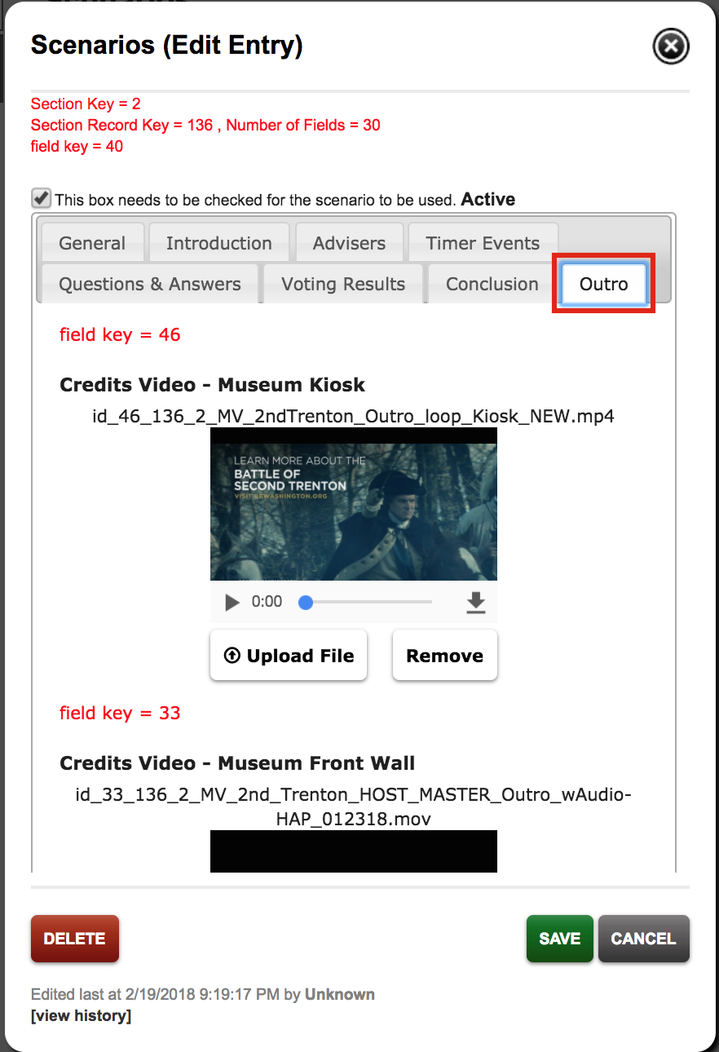The **Credits Video** for the museum kiosk is the media that appears at the end of the scenario. MP4 video file

The **Credit Video** for the museum front wall is the media that appears at the end of the scenario. This is a HAP MOV file.

The **Credits Slideshow** is a web-only theater feature popup. This has editable content for Image, Text Line 1, Text Line 2, Link Button Title, Link URL, and Slide Duration (Seconds).

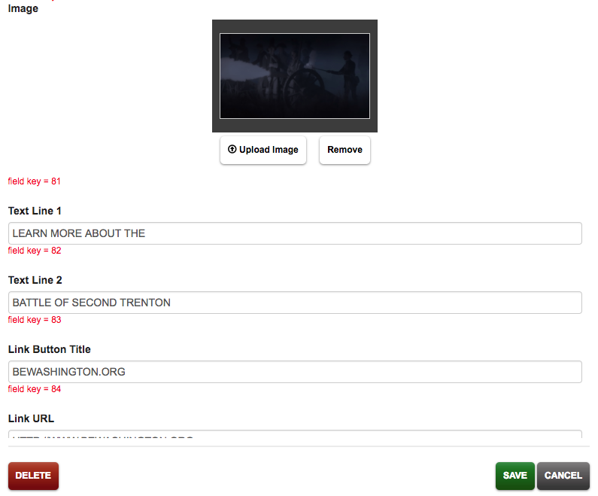**Image** refers to the picture that is in the background during the credits.

**Text Line 1** refers to the first half of the call to action text.

**Text Line 2** refers the second half of the call to action text.

**Link Button Title** refers to the text on the button that will link to bewashington.org.

The **Link URL** is the direct link to the Be Washington site. The URL MUST contain http:// or https:// to work.

**Slide Duration (Seconds)** refers to how long each slide in the credits stays on screen. It is currently set at 5 seconds.

## Web Only Data

When you select the **WEB ONLY DATA** tab on the top left of the screen, it will appear white. You will see editable content for the web version of Be Washington. This is where you change general **Web-Only** features not tied to any particular scenario.

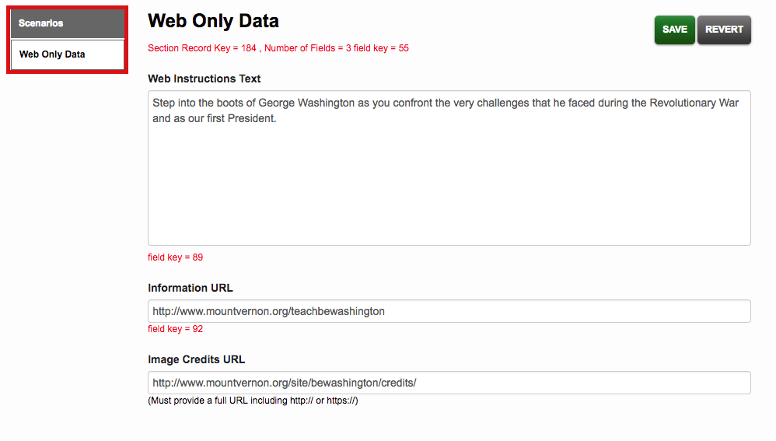The **Web Instructions Text** box contains text that appears on the home page when users first log on to play Be Washington on the web.

The **Information URL** is the link behind the question mark on the homepage.

The **Image Credits URL** is the link users will travel to when they press the button at the end of the credits.

# Settings

The **SETTINGS** tab, at the very top of the page, will bring you to a page that will allow you add or delete people who will have access to the CMS as a Viewer or as a Content Creator.



To add a new user, click the **Add New User** button on top left of the page. This will take you to a new page.

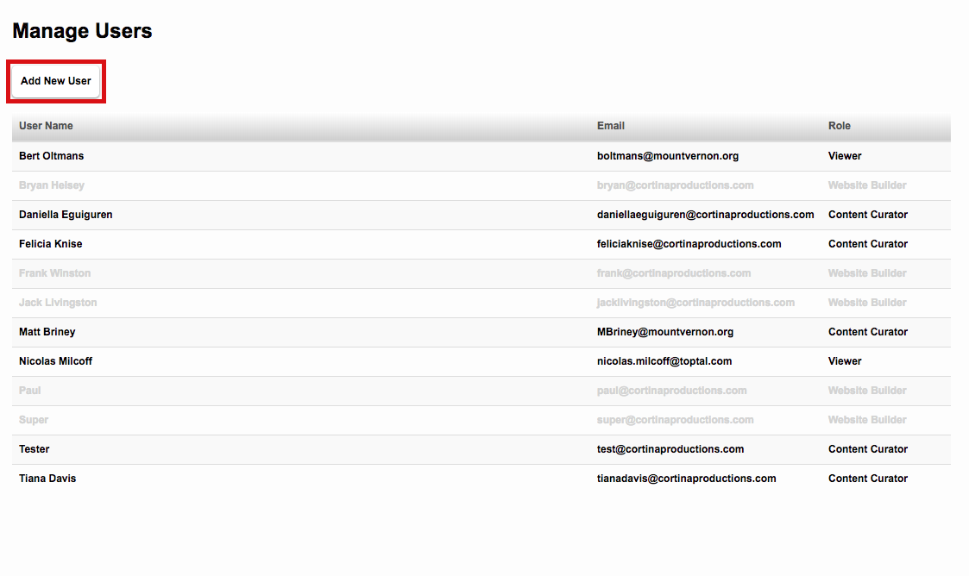

To register a new user, you will need to provide their name, password, email address, and what role they will play as it pertains to the CMS.

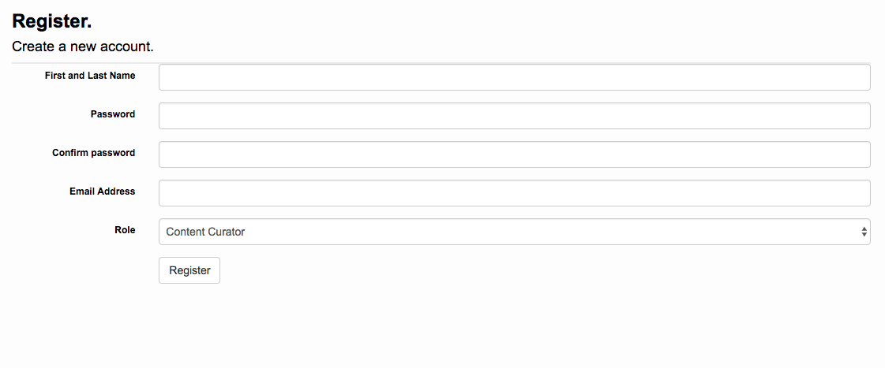

# User Profile

When you click **YOUR NAME** at the very top of the page, you will get the option to Change the Password to your account. You will need to provide your current password and then your new password. Clicking **YOUR NAME** is also how you log out of the CMS.

